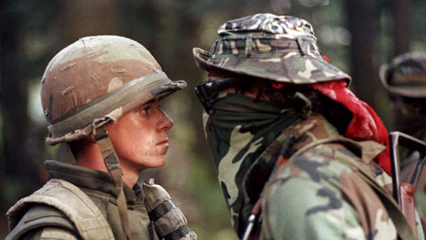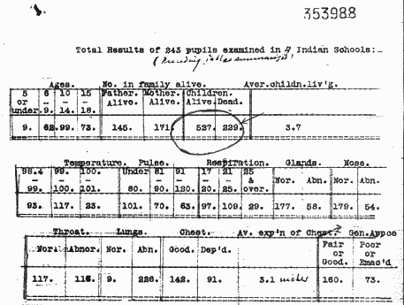
OKA Crisis | DATE: |  | Bryce Report | DATE:
DESCRIPTION |  |  | DESCRIPTION
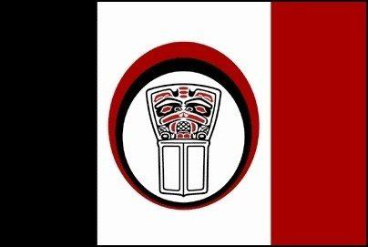
Allied Tribes of BC | DATE: |  | Nisga’a | DATE:
DESCRIPTION |  |  | DESCRIPTION
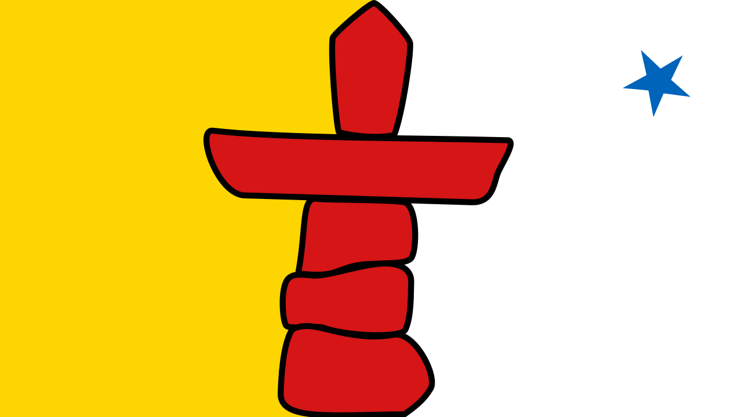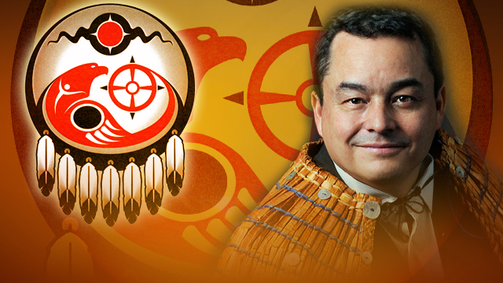
Nunavut | DATE: |  | UN Declaration of the Rights of Indigenous Peoples | DATE:
DESCRIPTION |  |  | DESCRIPTION

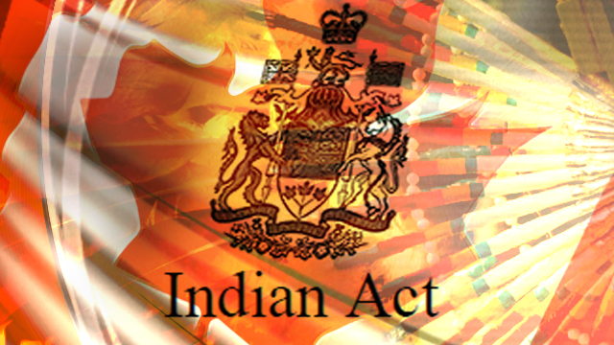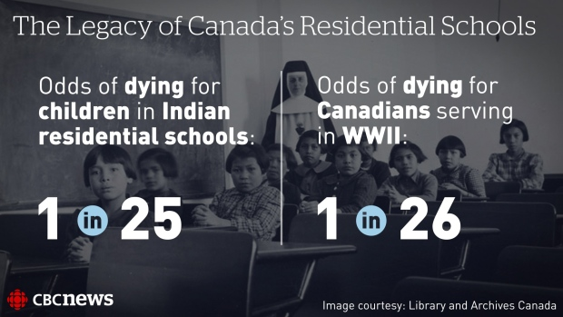
Indian Act | DATE: |  | Residential School System | DATE:
DESCRIPTION |  |  | DESCRIPTION
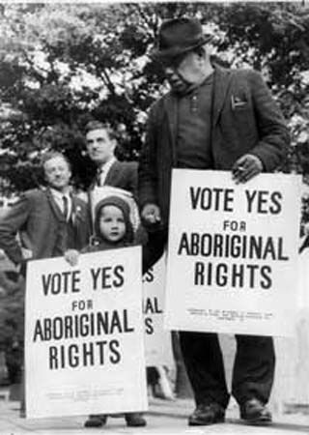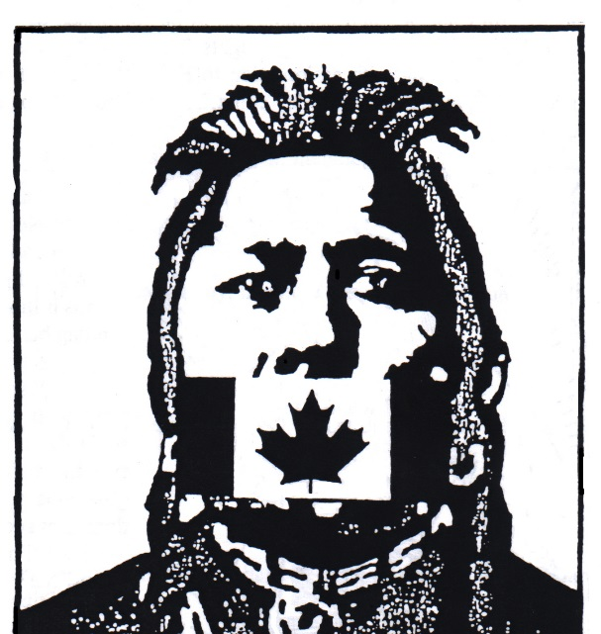
Right to Vote | DATE: |  | Section 141 of Indian Act | DATE:
DESCRIPTION |  |  | DESCRIPTION
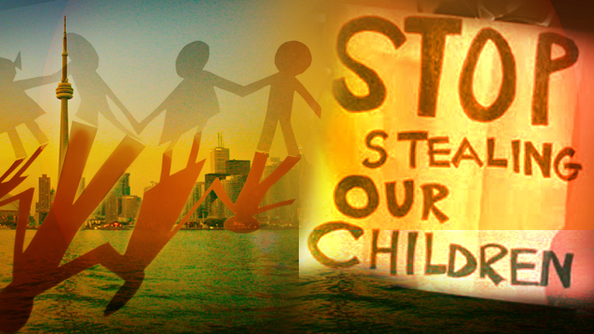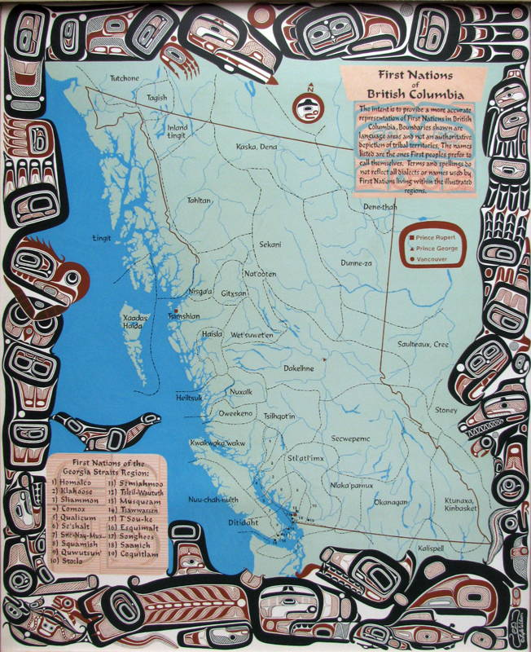
The 60’s“Scoop” | DATE: |  | Delgamuukw Case | DATE:
DESCRIPTION |  |  | DESCRIPTION

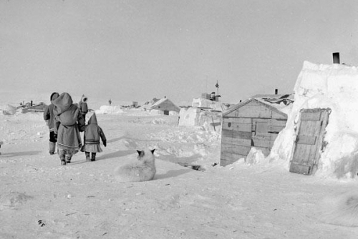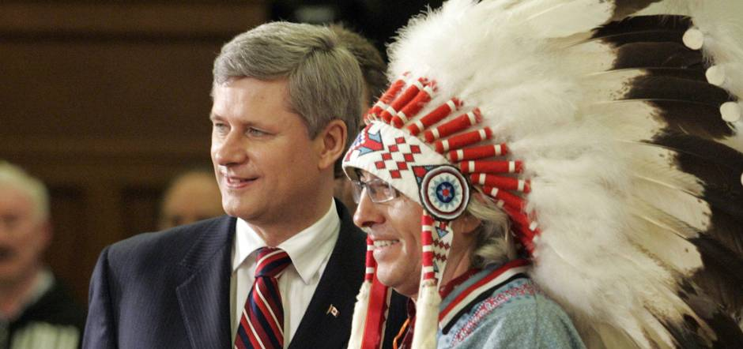
Arctic Relocation | DATE: |  | The Apology | DATE:
DESCRIPTION |  |  | DESCRIPTION

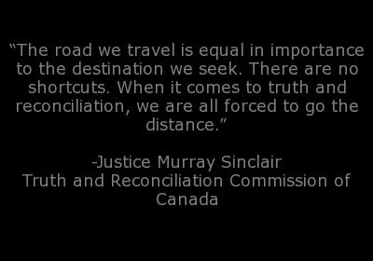
Royal Commission on Aboriginal Peoples | DATE: |  | Truth and Reconciliation commission | DATE:
DESCRIPTION |  |  | DESCRIPTION

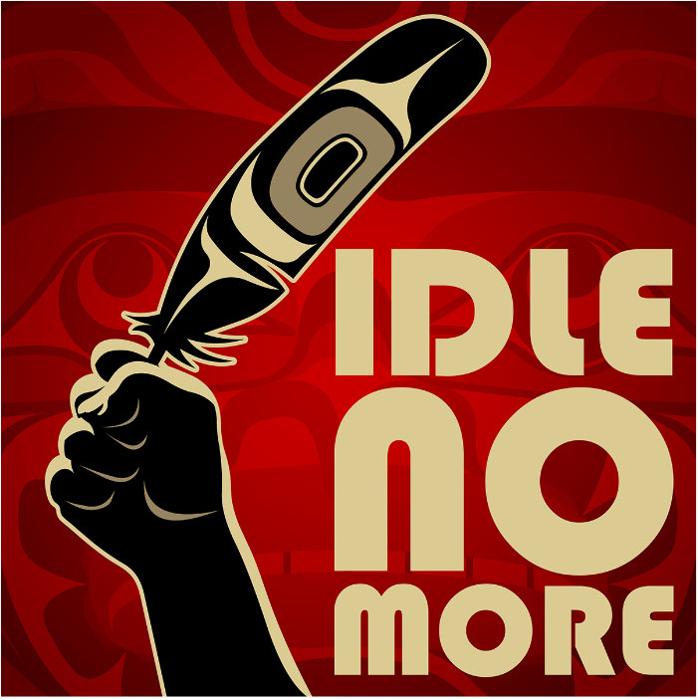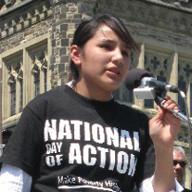
Idle No More | DATE: |  | Shannen’s Dream | DATE:
DESCRIPTION |  |  | DESCRIPTION
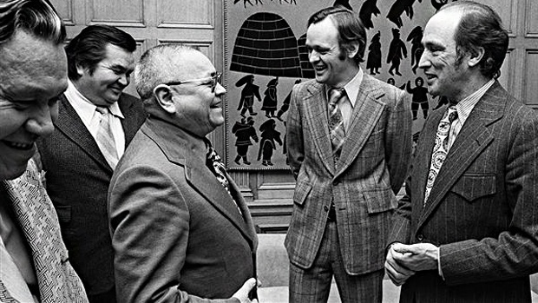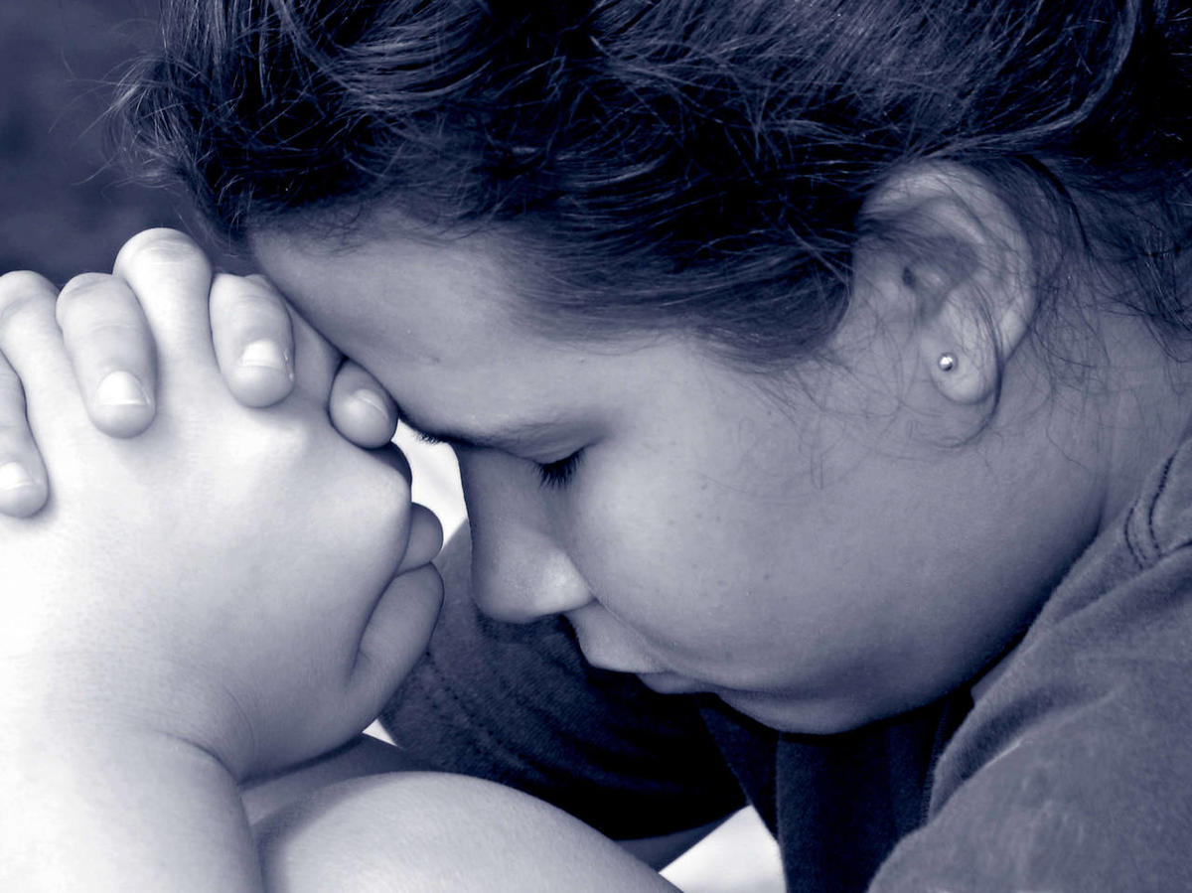
White Paper | DATE: |  | Suicide on Reservations | DATE:
DESCRIPTION |  |  | DESCRIPTION

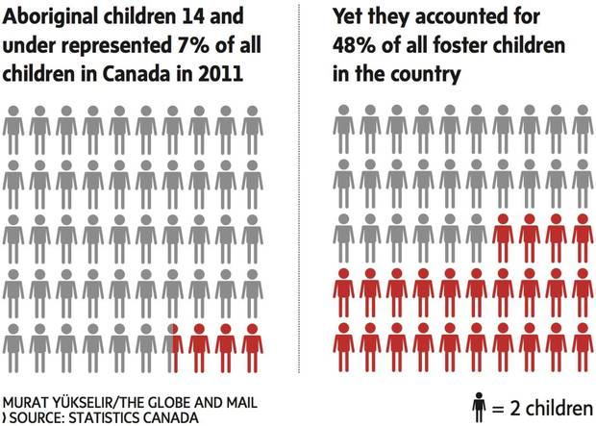
Incarceration rates | DATE: |  | Children in Care | DATE:
DESCRIPTION |  |  | DESCRIPTION

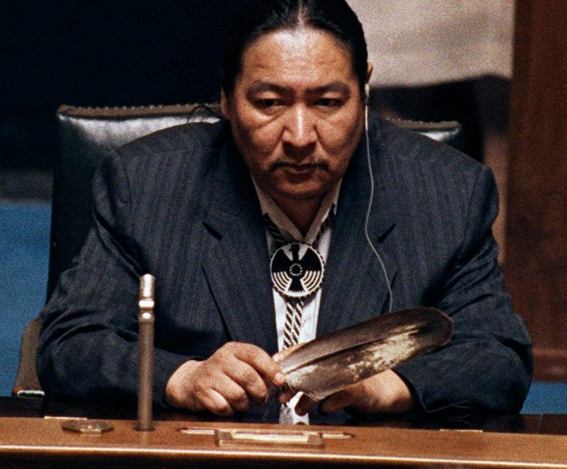
Meech Lake: Elijah Harper | DATE:
DESCRIPTION

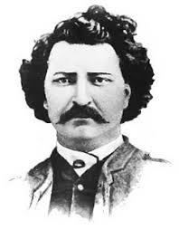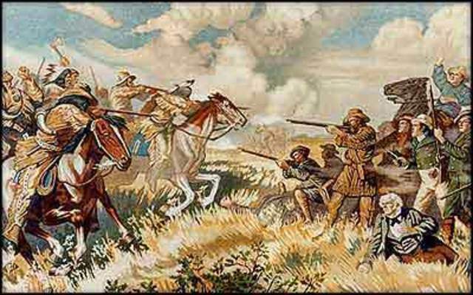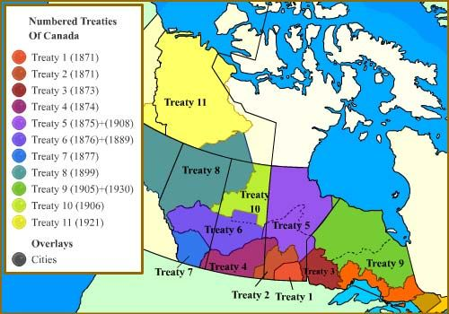
Louis Riel  Rebellion and execution | DATE: |  | Numbered Treaties | DATE:
DESCRIPTION |  |  | DESCRIPTION

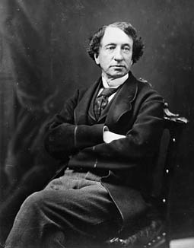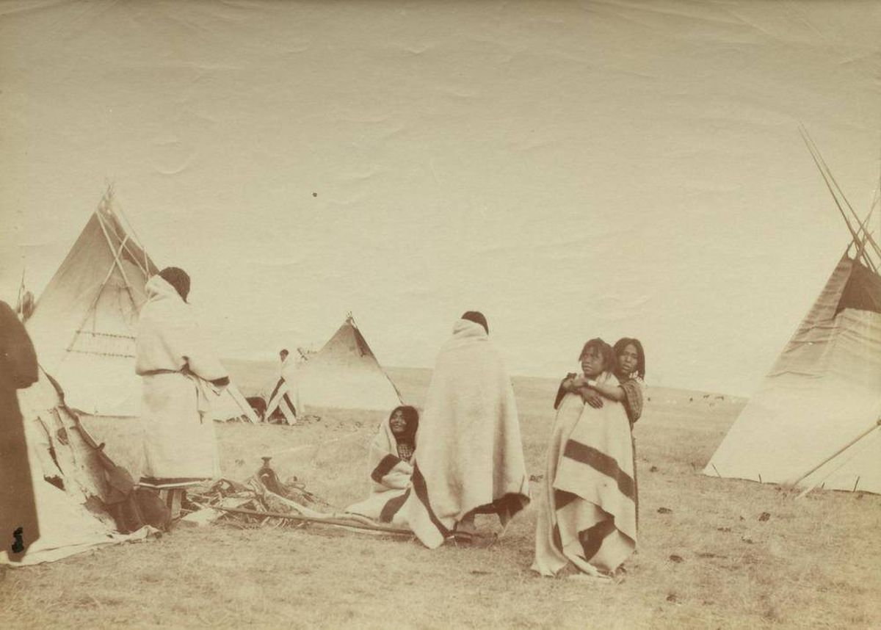
“Starve them one day, feed them the next” | DATE:
DESCRIPTION

