Why Colin Kaepernick sat down
San Francisco 49ers quarterback Colin Kaepernick believes his country attaches a low cost to Black lives. He's right, says Andray Domise.
By Andray DomiseAugust 30, 2016
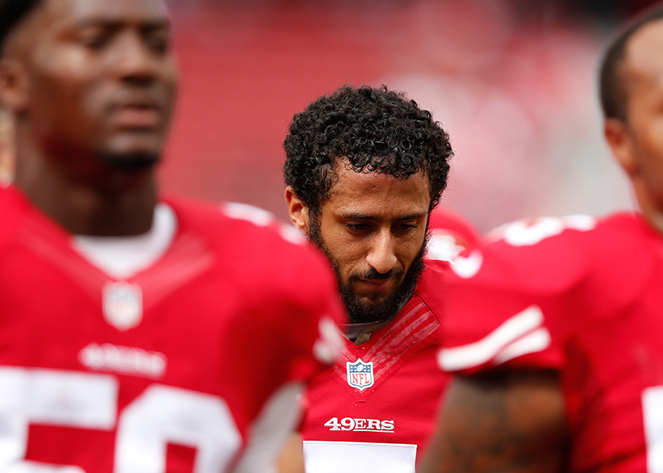
SANTA CLARA, CA – OCTOBER 18: Quarterback Colin Kaepernick #7 of the San Francisco 49ers warms up prior to playing the Baltimore Ravens in their NFL game at Levi’s Stadium on October 18, 2015 in Santa Clara, California. (Photo by Ezra Shaw/Getty Images)
Colin Kaepernick, backup quarterback for the San Francisco 49ers, touched off a firestorm last Friday in a pre-season game against the Green Bay Packers. As the teams stood on the field, and the rest of the stadium rose for the national anthem, Kaepernick remained seated in protest. When asked about it after the game, he told the NFL Network: “I am not going to stand up to show pride in a flag for a country that oppresses black people and people of colour.” He added: “To me, this is bigger than football and it would be selfish on my part to look the other way. There are bodies in the street and people getting paid leave and getting away with murder.”
It’s fitting that Kaepernick protested in Wisconsin, on the heels of demonstrations against the police killing of Sylville Smith in Milwaukee. Kaepernick himself was born in Wisconsin, and spent his early childhood in the suburb of Fond du Lac, about halfway between Green Bay and Milwaukee. Almost every relevant economic indicator ranks Wisconsin as one of the worst American states for Black people, including high incarceration rates, low family income, low net worth, and an outrageous achievement gap between Black and white students. Kaepernick’s hometown is only a short drive away from the Milwaukee neighbourhood of Bronzeville, a once-burgeoning Black neighbourhood whose homes were demolished by the Wisconsin government in the 1960s to make room for an interstate freeway. Wisconsin’s Black residents have, for decades, remained bounded by the purposeful segregations of urban design, economic immobility, and prison walls.
After Kaepernick made his comments, his social media accounts were deluged with racial slurs, wishes for season-ending injuries, and even videos of former fans burning his jersey. A common criticism (outside of exhortations that he go “back to Africa” to play football there) was that Kaepernick showed insufficient gratitude and respect for the flag, and the country that gave him the opportunity for a multi-million-dollar NFL contract. Drew Brees, quarterback for the New Orleans Saints, told ESPN: “Like, it’s an oxymoron that you’re sitting down, disrespecting that flag that has given you the freedom to speak out.” This was echoed by Jerry Rice, perhaps the greatest player to ever put on a 49ers jersey, when he tweeted, “All lives matter. So much going on in this world today. Can we all just get along! Colin, I respect your stance but don’t disrespect the Flag.”
Others, such as NBC analyst and former New England Patriot Rodney Harrison, alluded to the fact that, since Kaepernick was raised by white adoptive parents, he has no claim on personal oppression. Even Kaepernick’s biological mother, Heidi Russo, tweeted: “There’s ways to make change w/o disrespecting & bringing shame to the very country & family who afforded you so many blessings.”
Colin Kaepernick is the biological child of a white mother and Black father. Perhaps his racially ambiguous features helped reduce the social friction that comes packaged with Blackness. Perhaps his multi-million-dollar contract with the 49ers has provided a heat shield against racism. But Kaepernick identifies as a Black man in America, whose highest laws were originally drafted to the exclusion of Black people, and whose wealth was cultivated by a slave economy powered by kidnapped Black bodies. White Americans may have the convenience of honouring the flag without a true accounting of the atrocities committed under its aegis, but this is not so for Black America. In the eyes of Kaepernick’s critics, though, elite athletes exist in an imaginary plane outside of this reality and have no business bringing personal politics into the game.
Ignore, for a moment, that American athletes are regularly lauded for open displays of patriotism. Also put aside the fact that professional and college teams have raked in millions of dollars from the Pentagon for military tributes. Consider that Kaepernick plays in the NFL, a league whose troubled racial history has led to Black men comprising 68 per cent of players, 16 per cent of the head coaches, and none of the owners. Where an East Coast team is still named for a slur against Native Americans, and where Richie Incognito can racially abuse a Black teammate into leaving the Miami Dolphins, yet land a lucrative contract and earn a Pro Bowl selection a short time later. The NFL is where Kaepernick’s current coach, Chip Kelly, once came under fire for shutting out Black coaching staff during his tenure with the Philadelphia Eagles, and where the Eagles turned the other cheek in 2013 after wide receiver Riley Cooper threatened to “fight every nigger in here” at a Kenny Chesney concert.
The daily reminders that being born on American soil does not grant full protection of the American flag—this steady and pernicious accretion of proof—is yet another obstacle for Black athletes that neither their white peers nor white sports fans will ever know first-hand. When Black athletes do speak up, they know they will be hurt personally and professionally. This year, the WNBA assessed a $500 fine against players on the Indiana Fever, New York Liberty and Phoenix Mercury teams for wearing shirts referencing Black Lives Matter. That fine was only rescinded after a widespread backlash. And Minneapolis police officers walked off the job when Minnesota Lynx players wore the shirts to their pregame warm-up. The WNBA fine was rescinded after a widespread backlash, but the Minneapolis police union has maintained that officers will refuse to work the games if players continue to wear the shirts.
Former Denver Nuggets guard Mahmoud Abdul-Rauf fared much worse when he refused to stand for the national anthem 20 years ago. Seeing the American flag as a “symbol of oppression, of tyranny,” Abdul-Rauf weathered a league suspension, and ire from Denver sports media and Nuggets fans. His promising NBA career withered soon afterwards. This is to say nothing of the beloved and recently deceased Muhammad Ali, whose staunch anti-racism stance and refusal to fight in Vietnam nearly cost him everything. In his time, Ali was also called ungrateful, un-American, and far worse by critics who expected him to carry a gun in Vietnam, but would never themselves carry a protest sign alongside Black Americans.
Under the press of white supremacy in America, which applauds the virtue of nonviolent protest until it is exercised by Black people, Black athletes carry a social weight they neither want, nor asked for. How they reconcile that experience, their own beliefs, and America’s expectations toward them as role models is entirely up to them. Kaepernick obviously believes he owes something to the Black community, and finds his obligations incompatible with an American culture that places a low value on Black lives, and on holding police accountable. He earned his right to that belief through his life experience, and acquired his right to expression by birth, despite what his mother and so many others may think. Kaepernick wasn’t “given opportunities” by anyone. He worked and trained hard enough to be drafted by two teams in two different sports—the Chicago Cubs, and later the San Francisco 49ers. That work is all he owes his team, and all he owes an America that has yet to repay its own blood debt to Black Americans.
To those upset with a perceived lack of gratitude on his part, Colin Kaepernick owes nothing. And they should be ashamed for asking.
Andray Domise is a Toronto writer, activist and co-founder of txdl.ca, a mentorship and development program.

