Basic Economics
- What is Boom/ Bust?

- Example?

- What is “Economics”?

- What are 3 basic questions that Economics addresses?  - Example? | p. 286
- What is the law of Supply and Demand?  - Example? | p. 285
5. What is the global economy? | - Business and trade between multiple countries.
6. What is the Business Cycle?  - Why does the cycle move up and down?  - Does every recession result in a depression? | - Alternating periods of ups and downs in economic activity  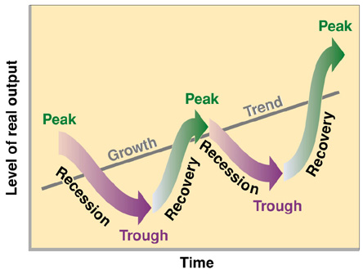
7. What are the 3 resources that every country/ business has? | p. 286  1.
- What are the 4 economic sectors?  (types of work)  - Why is the Primary Sector so Boom/Bust?  - Why do most Canadians work in the Tertiary sector? | - Primary:  - Secondary  - Tertiary  - Quaternary
- What is Gross Domestic Product? (GDP)

- What is Gross National Product? (GNP)

- What can you use that info for?

- What is Regional Disparity?

- What Physical Regions of Canada do you think have the weaker economy?

- Stronger Economy?

- What areas of Canada will have the largest populations? Why?

