Chester the false killer whale to stay at Vancouver Aquarium (with video)

BY BETHANY LINDSAY, VANCOUVER SUN MAY 26, 2015

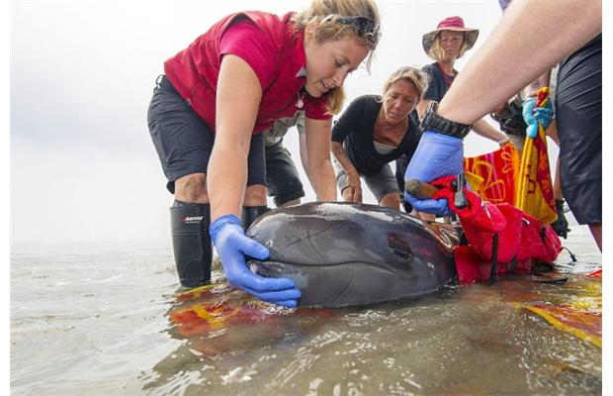
VANCOUVER -- A young false killer whale rescued from a beach near Tofino last summer will remain at the Vancouver Aquarium, where staff hope he will be a comfortable companion to the facility's one remaining dolphin.
Chester was wounded and emaciated when he was discovered stranded on North Chesterman Beach in July 2014. Rescuers were unable to locate his mother or any other members of his species in the area, and he was transferred into care at the aquarium's Marine Mammal Rescue Centre.
A panel of marine mammal experts convened by the Department of Fisheries and Oceans has determined that Chester cannot be released into the wild, officials announced Tuesday. The decision was based on his young age, lack of hunting and social skills, and extensive contact with humans.
The whale was just four to six weeks old and hadn't even grown teeth when he was stranded, according to Paul Cottrell, the DFO's marine mammal coordinator. He was at an age where calves are normally completely reliant upon their mothers.
"This animal was brand new," he told reporters.
Aquarium staff, including veterinarian Martin Haulena, "did an amazing job" nursing Chester back to health, Cottrell said.
This is the first time rescuers anywhere in the world have been able to save a juvenile false killer whale after stranding.
Chester weighed 76 kg and was just under 2 m long when he was rescued. Now, at about one year old, he has grown to weigh 174 kg and measure 2.36 m in length. Adult males of his species can grow to be 6 m long.
Haulena said that in the beginning, rescuers were not optimistic they would be able to save Chester. The aquarium's marine mammal staff have extensive experience dealing with stranded harbour porpoises, but false killer whales are a very different, and much larger, species of animal.
"To get him where he is today is an incredible accomplishment," Haulena said. "Chester looks amazing."
He described the animal as an energetic "goofball" who loves humans.
The news comes a day after the aquarium announced the death of Hana, a 21-year-old Pacific white-sided dolphin who veterinarians had tried to save with emergency intestinal surgery.
Aquarium staff had planned to introduce Chester to the tank that Hana shared with her fellow-dolphin Helen. They now hope that the young false killer whale will provide Helen with an opportunity to socialize following the loss of her companion.
Clint Wright, the aquarium's general manager and senior vice president, said that officials are looking into contingency plans in case the introduction does not go as planned. Only about 15 false killer whales are currently in captivity around the world, mainly in Asia.
He acknowledged that some anti-captivity activists might oppose keeping Chester in a tank at the aquarium.
"There's a portion of the population that believes these animals should be euthanized on the beach," he said. "We believe these animals do deserve a chance.
