Confederation Simulation
Character Bio Sheet

Character Name: _______________________ Colony: _________________________

***Remember to only record facts BEFORE the Confederation Conferences (in 1864)

Biography Notes:
Who are you? (born/ jobs/ etc.)
What is your View of Confederation?

At our conference, you will need to introduce your Character to the class.
Write a Paragraph Introduction:
_______________________________________________________________________________________________________________________________________________________________________________________________________________________________________________________________________________________________________________________________________________________________________________________________________________________________________________________________________________________________________________________________________________________________________________________________________________________________________________________________________________________________________________________________________________________________________________________________________________________________________________________________________________________________________________________________________________________________
Pre-Confederation
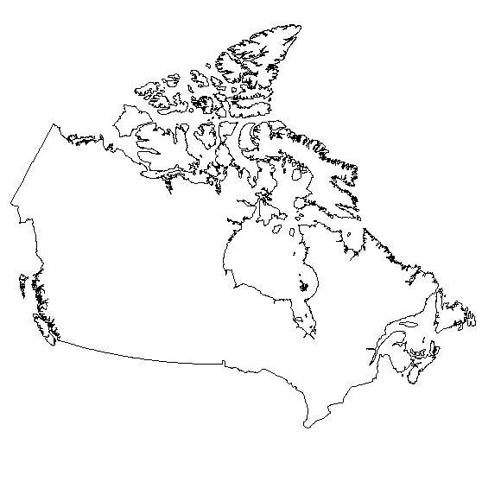
Colony Information sheet

On the Map of Eastern Canada:

- Colony Name:

- Capital City:

- Colour in your colony on the map provided

Use what you know from class, your class notes, the “Crossroads” textbook and the “Canada: revisited” Textbook to take notes/ discover what life was like in your colony before confederation.
Demographics:  (Where are people from/ language/ religion/ etc.) | What was life like?  (jobs / industry/ daily)
Problems facing your colony | other

