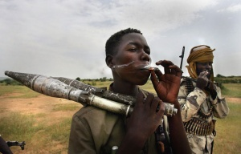
8 September 2004: Rebel fighters from the Sudanese Justice and Equality Movement (JEM) smoke rationed cigarettes at their base in Ulang, Sudan.
Scott Nelson/Getty Image

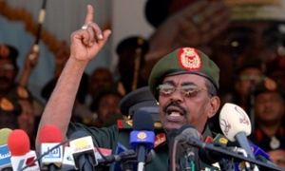
Sudanese president Omar al-Bashir, who has been in power for 25 years. Photograph: Phillip DHill/epa/Corbis
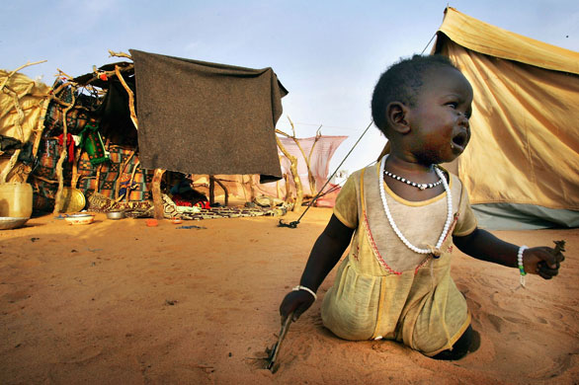
August 2004: A young Darfur refugee cries for her mother near her tent in the Oure Cassoni camp, in north-eastern Chad in August 2004. More than 18,000 refugees are in the camp but aid workers warn if the situation in Darfur does not improve soon, thousands more Sudanese could flood into neighbouring Chad, overwhelming the already strained resources
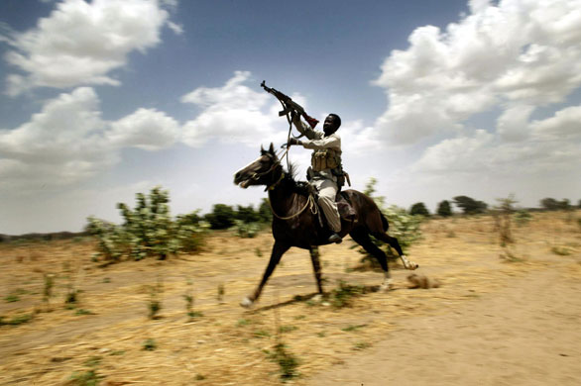
April 2004: A pro-government Arab militia fighter, known as the Janjaweed, in Sudan's west Darfur region near the Chadian border (Espen Rasmussen/AFP/Getty Images)
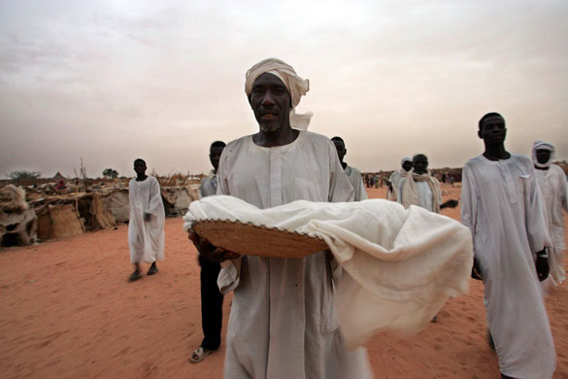
21 June 2004: A father carries the body of his one-year-old son Ali for burial at el-Geneina refugee camp, western Darfur. The boy died of malnutrition. More than 80,000 displaced people have reached Mornay to try to escape ethnic violence in the Darfur region. After surviving massacres by janjaweed, the refugees are now virtual prisoners in the camp, with the militias controlling the camp periphery, staging attacks and rape on villagers who venture out lookign for food
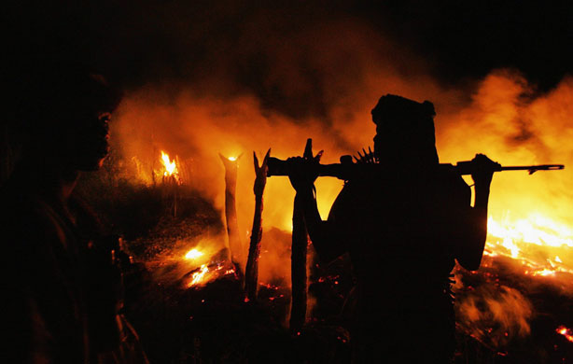
September 2004: An armed Sudanese rebel from the JEM arrives at the abandoned village of Chero Kasi, less than an hour after Janjaweed militiamen set it ablaze (Scott Nelson/Getty Images)
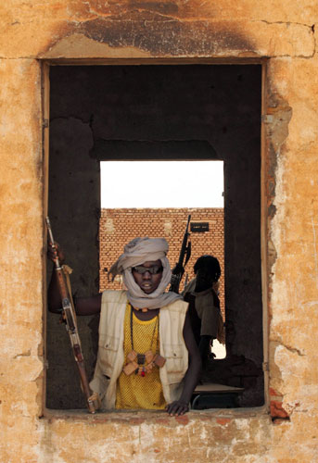

21 May 2006: Rebels from the Sudan Liberation Movement (SLM) occupy a deserted house in Tina, a small village abandoned by its residents after being attacked in March, south-west of El Fasher, the capital of the war-torn Sudanese northern Darfur region
Ramzi Haidar/AFP

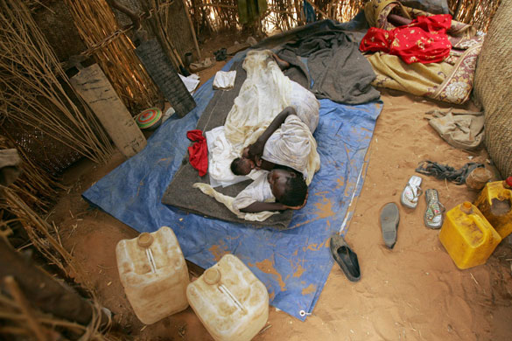
June 2006: A woman who has recently given birth holds her baby inside her shelter at ZamZam camp, a camp for refugees at El Fasher, northern Darfur. (Zohra Bensemra/Reuters)
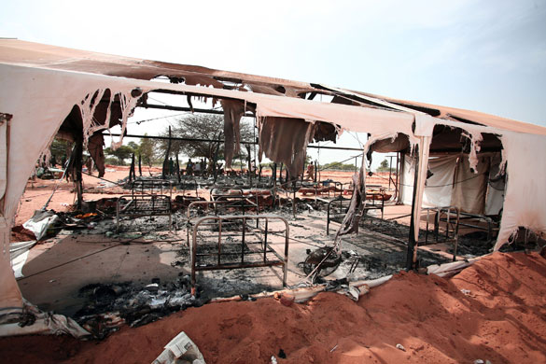
30 September 2007: A destroyed dormitory smoulders after an attack on the African Union camp in Haskanita. Rebel forces stormed a small AU base in northern Darfur, killing 10 peacekeepers in an unprecedented attack (Stuart Price/AP)

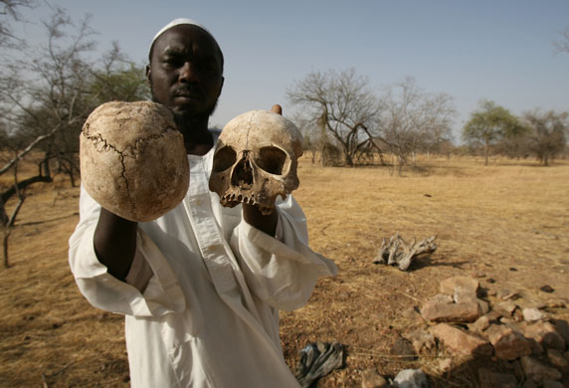
23 April 2007: Darfur survivor Ibrahim holds human skulls at the site of a mass grave where he says the remains of 25 of his friends and fellow villagers lie, on the outskirts of the west Darfur town of Mukjar (Nasser Nasser/AP)

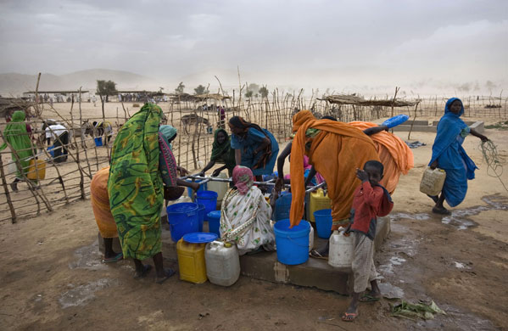
19 June 2008: Refugees from Darfur gather water at a well as a dust storm approaches Djabal camp near Gos Beida, eastern Chad (Finbarr O'Reilly/Reuter)
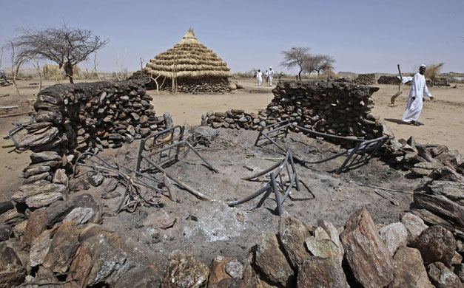

July 2008: A man walks past a gutted village home in Kafod, north Darfur. Prosecutor Luis Moreno-Ocampo has asked a three-judge panel at the International Criminal Court to issue an arrest warrant for President Omar al-Bashir on charges of genocide, accusing him of masterminding attempts to wipe out African tribes in Darfur (Stuart Price/Albany Associates/AP)

