French Revolution Poster and Presentation
(1-pager)

You will create a poster on 1 part of the French Revolution. You will be marked on your Research skills, including your notes, the content and writing ability, as well as the visual/ creative appeal. You will also be presenting your information to the class in groups. Be creative as well as informative!

What needs to be handed in:
- Poster complete with pictures, a clear title, and information on your topic
- Your notes
- An accurate and complete Bibliography (APA style)

****Please look at the rubric for where you earn your marks

DUE: ____________________________________________________________________________________________

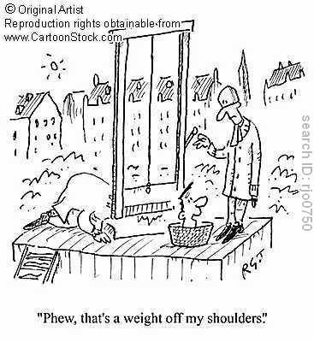

Possible Topics

People:
Please include the following information on your poster:
- Who they are (born/ childhood/ job/ etc)
- Role in the French Revolution (how they caused it/ participated in it)
- Your opinion on their role in Revolution
- Appropriate pictures/ visuals

- Marie Antoinette | - Jacques Danton
- King Louis XIV (Sun King) | - Jean-Paul Marat
- King Louis XVI | - Maximillen Robespierre

Events:
Please include the following information on your poster:
- What lead up to the event (causes)
- What happened
- Who was involved
- The significance of this event to the Revolution
- Appropriate pictures/ visuals

- Tennis Court Oath | - Execution of King Louis XVI
- The Storming of the Bastille | - Execution of Marie Antoinette
- Declaration of the Rights of Man and the Citizen | - Assassination of Marat (Charlotte Corday)
- Fish Woman’s March on Versailles | - Committee of Public Safety
- Royal escape attempt: Flight to Varennes | - Execution of Robespierre
- Robespierre’s Reign of Terror

