How to become a Fascist Dictator
How did Hitler gain power in Germany? What conditions were needed? What steps did he take? In this assignment you will analysis the events of the 1920s and 30s in Germany and create a guide for how to become a Fascist Dictator.
PART A: Recipe for a Totalitarian Government
Why do people follow totalitarian leaders? What are the “Key ingredients”? Use Hitler’s rise to power to create your recipe.
Format Choices:
- Recipe
- Instruction Manual
- You-tube instructional Video
Include:
- you must include the “ingredients” needed for fascism as outlined in class and in the textbook
  - this should look like the format you chose
- you must include the Specific Details of Hitler rise to power
- you may also include details from Stalin, Lenin, or Mussolini

PART B: Current Event Analysis
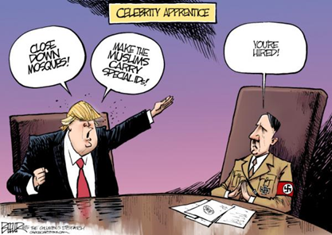
Apply the recipe/ instructions to a present-day example. Is a Fascist dictatorship a possibility in Canada or the USA today? Elsewhere?
Theme Choices:
- Fascism in Canada (Trudeau)
- Fascism in USA (Trump)
- other leader: Russia (Putin), etc.
Method:
- Apply the “ingredients” from your recipe to a current leader.
- Use 4-6 Current Events (find/ read)

format:
for Each current Event include the Headline and Source, a description of the action, and an explanation of whether this proves or disproves 1 of your criteria (ingredients)

Have a final Conclusion statement: Is that leader/ country in danger of becoming fascist?

NAME: __________________________________________

Recipe: Part A - Assessment Rubric
Needs improvement  1-3 | CRITERIA  1-6 | Well done  4-6
Understanding:
- Has identified the key elements needed to become a Fascist dictator
- Has included all the key historical events specific to Hitler (others)
- Demonstrates a clear understanding of the propaganda and power
Presentation:
- Neat, logical, clear design
- Great example of format chosen
- Creative
- Takes pride in work
comments:

Current Event Analysis – Part B - Assessment Rubric
Needs improvement  1-3 | CRITERIA  1-6 | Well done  4-6
Understanding:
- Has identified the key elements needed to become a Fascist dictator
- Has included all key current events/ facts needed for a good analysis
- Demonstrates a clear understanding of fascism
Presentation:
- Neat, logical, clear design
- Great example of format chosen
- Creative
- Takes pride in work
comments:

