**Life in New France**

**p.**

Structure of Seigneuries

Duties of the

Seigneur

Duties of the

Habitant

Habitant

C:\Users\sgoepel\AppData\Local\Microsoft\Windows\Temporary Internet Files\Content.IE5\DRJCIDCR\MC900280297[1].wmf



What is the difference between the Habitant and the Seigneur?

*Draw a sketch of the Seigneurial system*

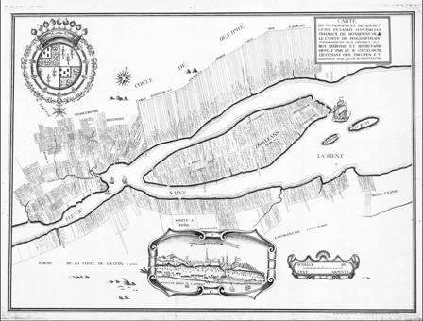

Why is being located by the river so important?