C:\Users\sgoepel\AppData\Local\Microsoft\Windows\Temporary Internet Files\Content.IE5\4XE6776C\MC900015060[1].wmfHow is New France **the Same** as France?

The Roman Catholic Church

In government

InI in Education

How is New France **DIFFERENT** from France?

In In Health Care

On the Seigneury



C:\Users\sgoepel\AppData\Local\Microsoft\Windows\Temporary Internet Files\Content.IE5\9K439D1M\MC900415468[1].wmf

C:\Users\sgoepel\AppData\Local\Microsoft\Windows\Temporary Internet Files\Content.IE5\DRJCIDCR\MC900198493[1].wmf

C:\Users\sgoepel\AppData\Local\Microsoft\Windows\Temporary Internet Files\Content.IE5\QJIVGELQ\MC900048128[1].wmf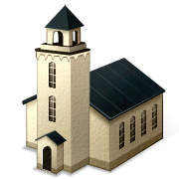

Women