Reading the Message in Political Cartoons

A political Cartoon is a drawing with a specific message. It is usually humorous, but can be serious. To get the message across, artists will use:

- Caricature: drawing of a person where 1 or more features are exaggerated
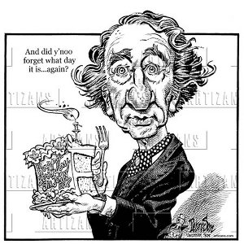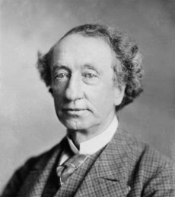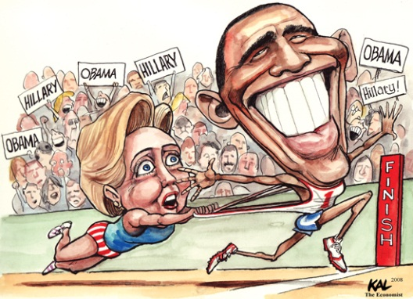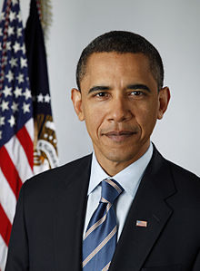

- Analogy: Using Historical, Cultural, and Literary references to convey the message
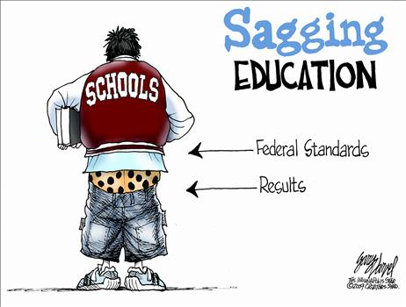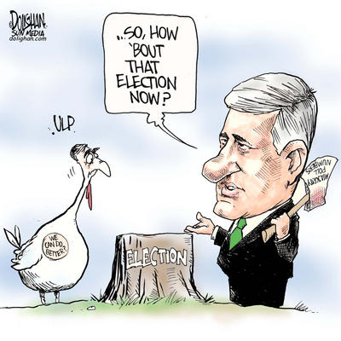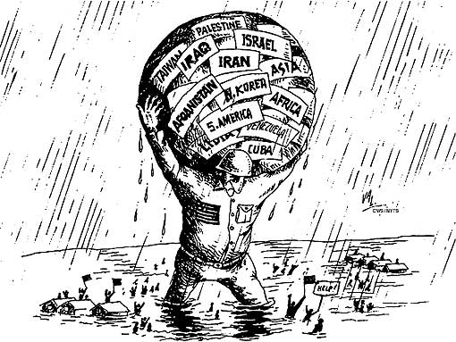

- Words: Titles, Captions, Dialogue, tags to explain the meaning of the image
**Read Everything!**

- Symbols: objects, facial expressions, images, colours, size, etc. with another meaning (aiding the message)
Example: Diamonds for wealth, skull for death, dove for peace.

Object | Meaning | Another object | Clothing/ costume | Possible issue
Top Hat | Wealth/ status | Diamond | Tuxedo | poverty
4 leaf clover
Icicle
Olive branch | Peace offering
pen | Communication
toque
sword
whip
For Each Country, list an animal, costume, object of word associated with that country
Country | Animal | Costume / clothing | Object/ word
Australia | Kangaroo | Bushman’s Hat | boomerang
Canada
France
China
United States

What meaning is associated with the following animals?
Animal | Meaning
Fox | Sly / cunning
Black cat
Lamb
Lion
Octopus
Peacock
Spider
Vulture
Wolf
monkey

What is the meaning/ message of this cartoon?
