Russian Revolution - ESSAY OPTIONS:

#1

“One does not establish a dictatorship in order to safeguard a revolution; one makes a revolution in order to establish a dictatorship.” George Orwell

Analyze this quote in the context of the Russian Revolution. Did Lenin intend to bring communism to Russia?

#2

“Ideas are more powerful than guns. We would not let our enemies have guns, why should we let them have ideas?” Joseph Stalin

Analyze this quote in the context of Stalin’s method of leadership in the USSR from 1924 to 1939. Why was Stalin able to maintain his power?

(consider both USSR citizens and International leaders in your answer)

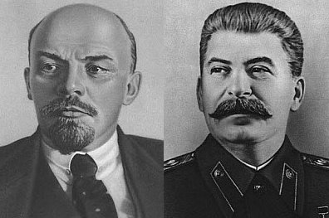

"One death is a tragedy; one million is a statistic." Joseph Stalin

“A lie told often enough becomes the truth” Vladimir Lenin

“Show me who your friends are, and I will tell you what you are.” Vladimir Lenin

NOTE:

Essays must be typed in 12-font, with a Chicago-style cover page and appropriate Footnotes or Endnotes

Sample Cover Page

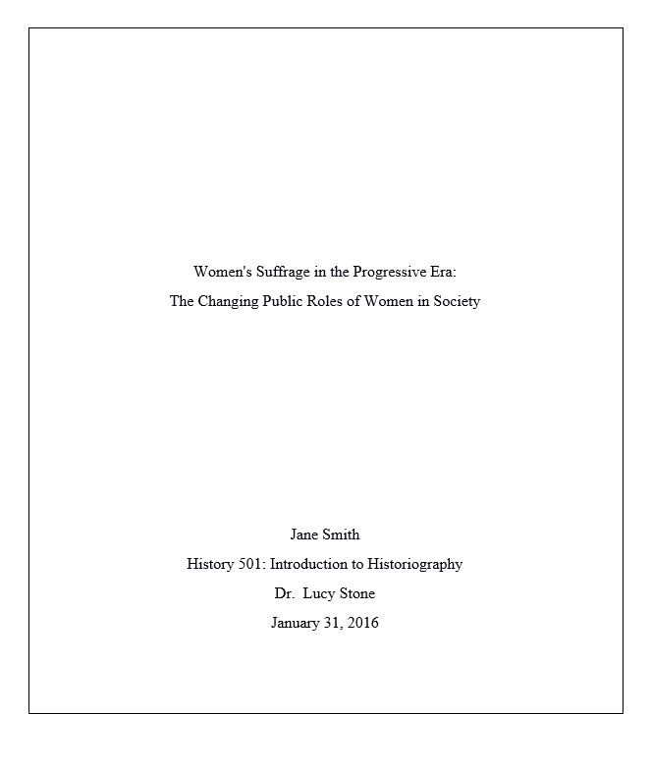

Footnotes – Chicago Bibliography

***can use www.bibme.org to help**

- In Chicago style, footnotes or endnotes are used to reference pieces of work in the text.
- To cite from a source a superscript number is placed after a quote or a paraphrase.
- Citation numbers should appear in sequential order.
- Each number then corresponds to a citation, a footnote or to an endnote.
- Endnotes must appear on an endnotes page. The page should be titled Notes (centered at top). This page should appear immediately before the bibliography page.
- Footnotes must appear at the bottom of the page that they are referred to.
Example:
Cole found that "The bones were very fragile".¹
Each superscript then refers to a numbered citation in the footnotes or endnotes.
Footnotes/endnotes:
The first time the in-text reference is cited you must include, author's first name, author's last name, title, place of publication, publisher name, year and referenced pages. e.g.
1. James Smith, The first and last war, (New York, Hamilton, 2003), 2.
If the citation has already been cited it may be shortened to author's last name, shortened title, and page referenced number. e.g.
2. Smith, The first, 220-221.

