Syria: The story of the conflict (BBC)
12 March 2015

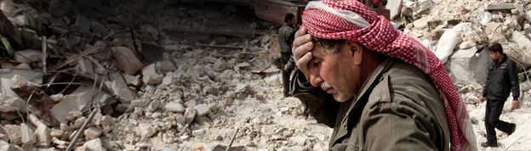
More than 200,000 Syrians have lost their lives in four years of armed conflict, which began with anti-government protests before escalating into a full-scale civil war. More than 11 million others have been forced from their homes as forces loyal to President Bashar al-Assad and those opposed to his rule battle each other - as well as jihadist militants from Islamic State. This is the story of the civil war so far, in eight short chapters.

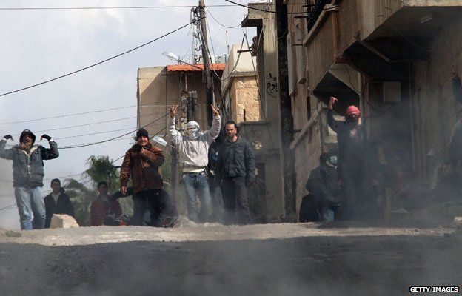
1. Uprising turns violent
Pro-democracy protests erupted in March 2011 in the southern city of Deraa after the arrest and torture of some teenagers who painted revolutionary slogans on a school wall. After security forces opened fire on demonstrators, killing several, more took to the streets.
The unrest triggered nationwide protests demanding President Assad's resignation. The government's use of force to crush the dissent merely hardened the protesters' resolve. By July 2011, hundreds of thousands were taking to the streets across the country.
Opposition supporters eventually began to take up arms, first to defend themselves and later to expel security forces from their local areas.
___________________________________________________________________________________________

2. Descent into civil war

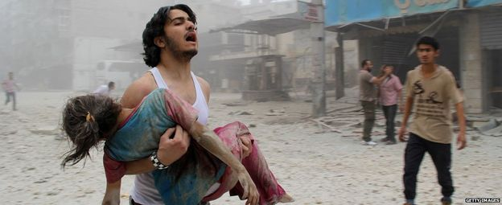
Violence escalated and the country descended into civil war as rebel brigades were formed to battle government forces for control of cities, towns and the countryside. Fighting reached the capital Damascus and second city of Aleppo in 2012.
By June 2013, the UN said 90,000 people had been killed in the conflict. However, by August 2014 that figure had more than doubled to 191,000 - and continued to climb to 220,000 by March 2015, according to activists and the UN.
The conflict is now more than just a battle between those for or against President Assad. It has acquired sectarian overtones, pitching the country's Sunni majority against the president's Shia Alawite sect, and drawn in neighbouring countries and world powers. The rise of the jihadist groups, including Islamic State, has added a further dimension.

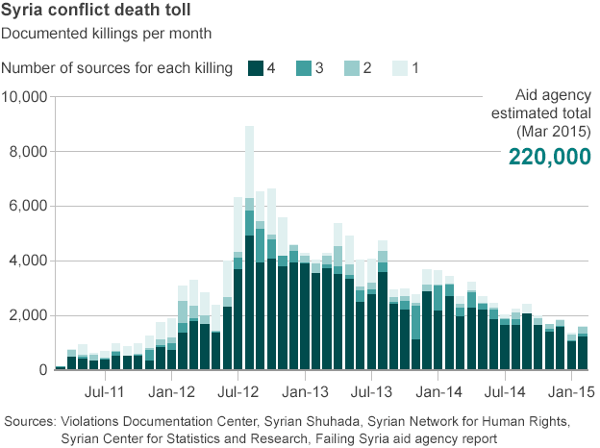

3. War crimes
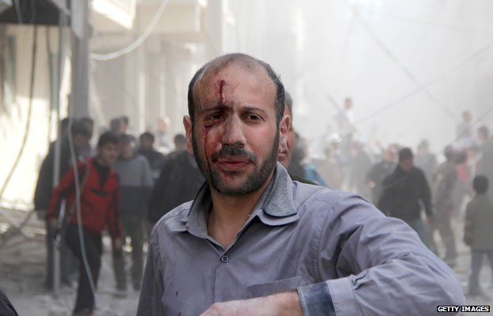
A UN commission of inquiry, investigating alleged human rights violations since March 2011, has evidence that those on both sides of the conflict have committed war crimes - including murder, torture, rape and enforced disappearances. Government and rebel forces have also been accused by investigators of using civilian suffering, such as blocking access to food, water and health services, as a method war.
In February 2014, a UN Security Council resolution demanded all parties end the "indiscriminate employment of weapons in populated areas". Since then, activists say more than 6,000 civilians have been killed by barrel bombs dropped by government aircraft on rebel-held areas. The UN says in some instances, civilian gatherings have been deliberately targeted, constituting massacres.
Islamic State has also been accused by the UN of waging a campaign of terror in northern and eastern Syria. It has inflicted severe punishments on those who transgress or refuse to accept its rule, including hundreds of public executions and amputations. Its fighters have also carried out mass killings of rival armed groups, members of the security forces and religious minorities, and beheaded hostages, including several Westerners.
We're just living on the edge of life. We're always nervous, we're always afraid
Mother-of-nine Mariam Akash, whose husband was killed by a sniper
Getty Images

4. Chemical weapons
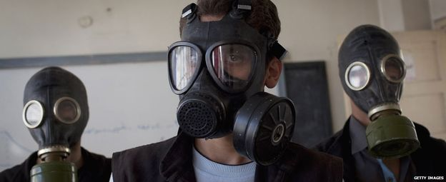
Hundreds of people were killed in August 2013 after rockets filled with the nerve agent sarin were fired at several agricultural districts around Damascus. Western powers, outraged by the attack, said it could only have been carried out by Syria's government. The regime and its ally Russia blamed rebels.
Facing the prospect of US military intervention, President Assad agreed to the complete removal or destruction of Syria's chemical weapons arsenal as part of a joint mission led by the UN and the Organisation for the Prohibition of Chemical Weapons (OPCW). The destruction of chemical agents and munitions was completed a year later.
Despite the operation, the OPCW has since documented the use of toxic chemicals, such as chlorine and ammonia, by the government in attacks on rebel-held northern villages between April and July 2014 that resulted in the deaths of at least 13 people.

Alleged Chemical Attacks

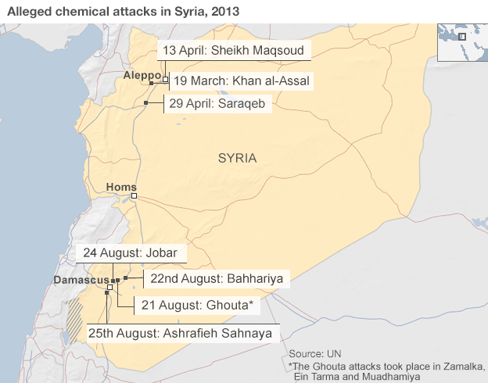

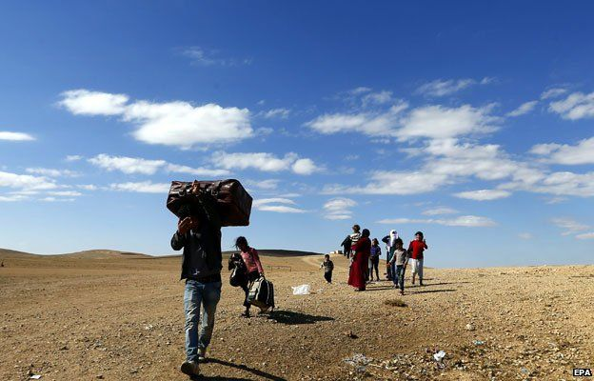
5. Humanitarian crisis Syrian refugees in the region
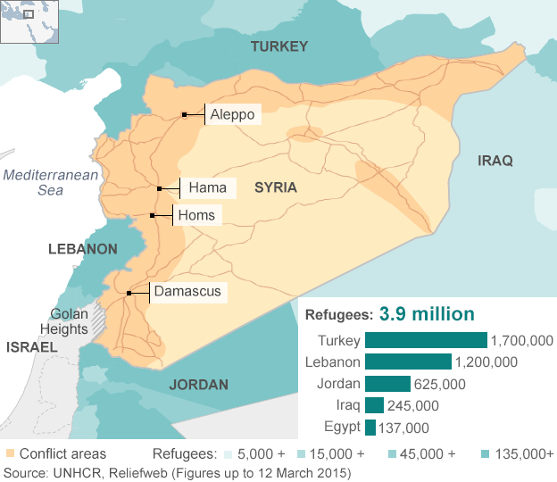

Almost 4 million people have fled Syria since the start of the conflict, most of them women and children. It is one of the largest refugee exoduses in recent history. Neighbouring countries have borne the brunt of the refugee crisis, with Lebanon, Jordan and Turkey struggling to accommodate the flood of new arrivals. The exodus accelerated dramatically in 2013, as conditions in Syria deteriorated.
A further 7.6 million Syrians have been internally displaced within the country, bringing the total number forced to flee their homes to more than 11 million - half the country's pre-crisis population. Overall, an estimated 12.2 million are in need of humanitarian assistance inside Syria, including 5.6 million children, the UN says.
In December 2014, the UN launched an appeal for $8.4bn (£5.6bn) to provide help to 18 million Syrians, after only securing about half the funding it asked for in 2014.
A report published by the UN in March 2015 estimated the total economic loss since the start of the conflict was $202bn and that four in every five Syrians were now living in poverty - 30% of them in abject poverty. Syria's education, health and social welfare systems are also in a state of collapse.

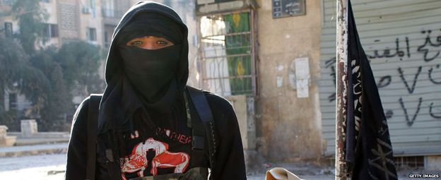
6. Rebels and the rise of the jihadists
The armed rebellion has evolved significantly since its inception. Secular moderates are now outnumbered by Islamists and jihadists, whose brutal tactics have caused widespread concern and triggered rebel infighting.
Capitalising on the chaos in the region, Islamic State (IS) - the extremist group that grew out of al-Qaeda in Iraq - has taken control of huge swathes of territory across northern and eastern Syria, as well as neighbouring Iraq. Its many foreign fighters in Syria are now involved in a "war within a war", battling rebels and jihadists from the al-Qaeda-affiliated Nusra Front, who object to their tactics, as well as Kurdish and government forces.
In September 2014, a US-led coalition launched air strikes inside Syria in an effort to "degrade and ultimately destroy" IS, ultimately helping the Kurds repel a major assault on the northern town of Kobane.
In the political arena, rebel groups are also deeply divided - with rival alliances battling for supremacy. The most prominent is the moderate National Coalition for Syrian Revolutionary and Opposition Forces, backed by several Western and Gulf Arab states. However, the coalition has little influence on the ground in Syria and its primacy is rejected by other groups, leaving the country without a convincing alternative to the Assad government.

US-led coalition airstrikes in Syria and Iraq
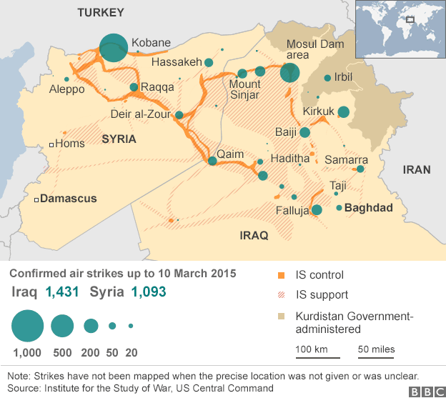

7. Peace efforts

With neither side able to inflict a decisive defeat on the other, the international community long ago concluded that only a political solution could end to the conflict in Syria. However, a number of attempts by the Arab League and the UN to broker ceasefires and start dialogue have failed.
In January 2014, the US, Russia and UN convened a conference in Switzerland to implement the 2012 Geneva Communique, an internationally-backed agreement that called for the establishment of a transitional governing body in Syria formed on the basis of mutual consent.
The talks, which became known as Geneva II, broke down in February after only two rounds. The then UN special envoy Lakhdar Brahimi blamed the Syrian government's refusal to discuss opposition demands and its insistence on a focus on fighting "terrorists" - a term Damascus uses to describe rebel groups.
UN Secretary General Ban Ki-moon says the organisation's long-term strategic objective remains a political solution based on the Geneva Communique. The UN special envoy Staffan de Mistura has also proposed establishing a series of "freeze zones", where local ceasefires would be negotiated to allow aid deliveries in besieged areas. But his attempt to broker a truce in Aleppo has been rejected by rebels in the city, who fear the government will use it to redeploy its forces elsewhere and that IS militants will simply ignore it.

8. Proxy war

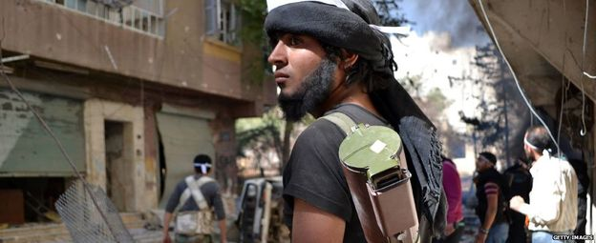
What began as another Arab Spring uprising against an autocratic ruler has mushroomed into a brutal proxy war that has drawn in regional and world powers.
Iran and Russia have propped up the Alawite-led government of President Assad and gradually increased their support, providing it with an edge that has helped it make significant gains against the rebels. The government has also enjoyed the support of Lebanon's Shia Islamist Hezbollah movement, whose fighters have provided important battlefield support since 2013.
The Sunni-dominated opposition has, meanwhile, attracted varying degrees of support from its main backers - Turkey, Saudi Arabia, Qatar and other Arab states along with the US, UK and France. However, the rise of hardline Islamist rebels and the arrival of jihadists from across the world has led to a marked cooling of international and regional backing.
The US is now arming a 5,000-strong force of "moderate" rebels to take the fight to IS on the ground in Syria, and its aircraft provide significant support to Kurdish militia seeking to defend three autonomous enclaves in the country's north.
The disappointment caused by the West's inaction created a fertile recruiting ground for extremists, who told those who had lost their loved ones that they were their only hope
Majed, a 26-year-old civil society activist
Getty Images
Produced by Lucy Rodgers, David Gritten, James Offer and Patrick Asare

