INSTRUCTIONS:
August 15, 1961 – the Berlin Wall has been up for 1 day, and is the top story in the world.
What happened, according to West Germay? Why was the wall put up? What does it symbolize?
Complete the following Newspaper article Template from the perpsective of West Germany.

Resources: (Take notes!!)
- Video Lesson
- Video: https://youtu.be/myW1Padwxqk

August 15, 1961

YOUR HEADLINE IS HERE
The Best News Source in West Germany
THE
WEST NEWS

By (your Name Here)

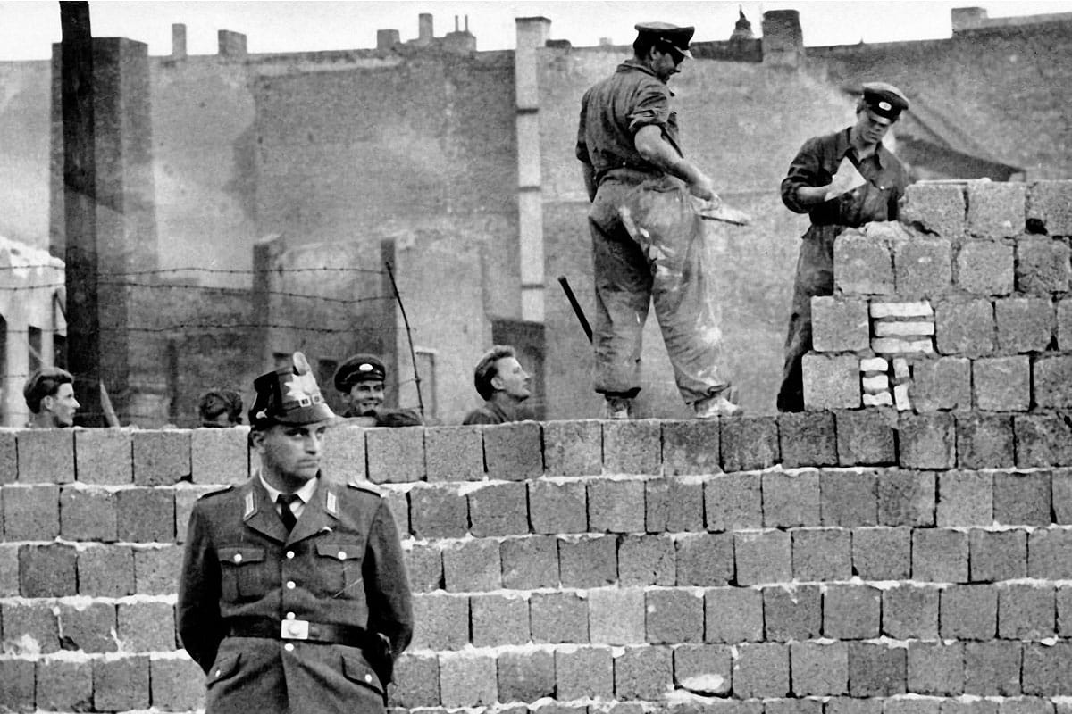

TYPE the article here –

What happened? What details would the west emphasize?

Why did they put up the wall?

Whose fault is it/ who is responsible?

What does it mean for the cold war?

continue article here (and feel free to change the picture)

INSTRUCTIONS:
August 15, 1961 – the Berlin Wall has been up for 1 day, and is the top story in the world.
What happened, according to The Democratic Republic of Germany (East Germany)? Why was the wall put up? What does it symbolize?
Complete the following Newspaper article form the perpsective of West Germany.

Resources: (Take notes!!)
- Video Lesson
- Video: https://youtu.be/myW1Padwxqk
- additional resource: DRG pamphlet: Https://research.calvin.edu/german-propaganda-archive/wall.htm

August 15, 1961

YOUR HEADLINE IS HERE
THE
EAST NEWS

published in the Democratic Republic of Germany

By (your Name Here)

TYPE the article here –

What happened? What details would the East emphasize?

Why did they put up the wall?

Whose fault is it/ who is responsible?

What does it mean for the cold war?

continue article here (and feel free to change the picture)

