The Rise of Totalitarianism
Watch “Love, Hate and Propaganda: The Strongmen (episode 1)”
https://curio.ca/en/video/love-hate-and-propaganda-the-strongmen-part-1-of-6-1162/

What can we learn about each of these totalitarian leaders as WW2 begins? take notes on the video.
(you can take notes on your own paper/ format if you want; you do not have to use this sheet)
Germany: Adolf Hitler  Nazism (Fascism)  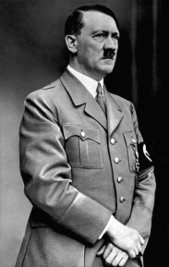 | Italy: Benito Mussolini  Fascism  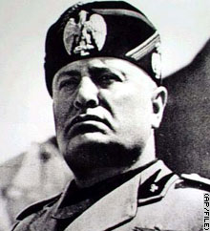
Russia: Joseph Stalin  Communism  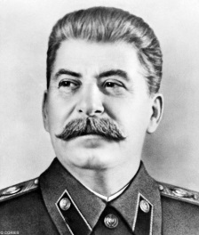 | Japan: Hirohito  Emperor  