Russian Revolution NOTES

1904:  Russo-Japanese War | Description/ Notes | Significance? (Impact on culture, society, economy, later events?)
  - Humiliation and defeat (economic defeat as well)
  - 89,000 Russians dead
  - Worst Naval disaster in Russian History

1905 Revolution: | Description/ Notes | Significance? (Impact on culture, society, economy, later events?)
    - Father George Gapon calls a strike when 4 workers in Petrograd are fired – in two weeks 120,000 workers are on strike
    - Strikers March on Winter palace – Palace guards fire into the crowd, 200 killed, 800 wounded. (Bloody Sunday)
    - Gains: Tsar Promises in the “October Manifesto” civil liberties (such as free speech) and an Elected “DUMA” (parliament) to make the laws
    - Reality: Totalitarian Gov. remains - Tsar appoints the Duma and he approves all laws (Duma has no real power)

1914 - 1917  Russia in  WW1 | Description/ Notes | Significance? (Impact on culture, society, economy, later events?)
- Railways support troops, not cities, and food shortages and starvation results on the home front
- Enormous casualty rates on the front lines (4 million dead in 1914)

- 1915 – Tsar Nicholas moves to the front lines to lead the troops – now is personally blamed
- Wife, Alexandra, and through her, Rasputin, rule at home (Rasputin is assassinated in Dec. 1916)

- Germany encouraged nationalist movements in Poland, Finland, and Ukraine (including Lenin and the Bolsheviks) to destabilize Russia

- Massive Russian Desertion from Front Lines (2 million by 1917)

- 1917: Bread, Coal Shortage, exceptionally cold winter

1917  March Revolution | Description/ Notes | Significance? (Impact on culture, society, economy, later events?)

1917  Lenin  and  “April Thesis” | Description/ Notes | Significance? (Impact on culture, society, economy, later events?)
- Germany smuggles Lenin back into Russia – hopes to create chaos and cause Russia to exit WW1
- April Thesis = speech promising peace, seizure of land and factories form wealthy, power to soviet people
- SLOGAN+
“______________, ___________, and _____________!”

1917  July Days | Description/ Notes | Significance? (Impact on culture, society, economy, later events?)

1917  October Revolution  (Bolshevik Revolution) | Description/ Notes | Significance? (Impact on culture, society, economy, later events?)

Cost of Peace:  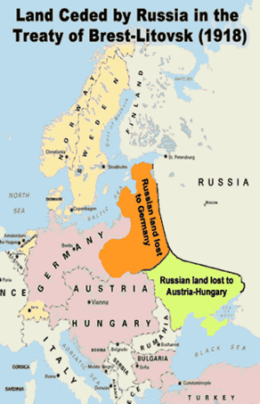  terms of the Treaty of Brest-Litovsk (1917)  Land lost included:  - 60 million people / 26% of population  (Finland, Ukraine, Poland, Lithuania, Estonia, Latvia gain independence)  - 26% of railway system  - 33% of manufacturing  - 27% of farmland  - 73% of iron industry  - 75% of coal mines | Significance?

1918- 1921  Civil War  (Red Bolsheviks vs. White ) | Description/ Notes | Significance? (Impact on culture, society, economy, later events?)

1918- 1921  War Communism | Description/ Notes | Significance? (Impact on culture, society, economy, later events?)

1921  New Economic Policy  (NEP) | Description/ Notes | Significance? (Impact on culture, society, economy, later events?)

1921  Treaty of Rapallo | Description/ Notes | Significance? (Impact on culture, society, economy, later events?)

1922  1924 | Description/ Notes | Significance? (Impact on culture, society, economy, later events?)
- Bolshevik Party becomes “Communist Party” or “Party”
- Russia changes its name to Union of Soviet Socialist Republics (USSR)

- Lenin dies January, 1924
(he had been shot in 1921, and it never fully recovered)

